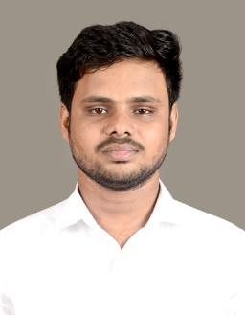Harshavarthan R 

CSD Intern

Email ID: 2397798@cognizant.com

Mobile: +919176757874

Address: 7A, Balaji Nagar, Vinayakapuram, Chennai-600099, Tamil Nadu.

LinkedIn: https://www.linkedin.com/in/harshavarthan-r-a5b9a8281

**CAREER OBJECTIVE**

Looking forward to associating myself with an organization, where there is an opportunity to share, contribute and upgrade my knowledge for the development of self and organization served.

**WORK EXPERIENCE**



**CSD Intern | Mar 2025 – Present**

Currently undergoing training program on CNAIP where I’m learning Azure Fundamentals, Jenkins, Maven, Ansible, Git, Docker,etc, gaining strong core and technical knowledge in these courses.

**ACADEMIC QUALIFICATION**

* **Velammal Engineering College.**

BE, Computer Science and engineering | 2021 – 2025 | CGPA – 8.3

* **Velammal Vidyalaya Mel Ayanambakkam.**

Class 12 | 2020 - 2021 | 80.8%

* **Vidya Peetam Senior Secondary School.**

Class 10 | 2018 - 2019 | 74%

**PROFESSIONAL SKILLS**

* Software skills known: Azure, Git , jenkins.
* Programming skills known: Basics of SQL, JAVA.
* Adapting to any environment or culture.
* Ability of willingness to learn new things.
* Ability to work independently or as a part of a team.
* Hard worker and has the ability to motivate myself and others.
* Good at oral and written communication

**PROJECT WORK**

* **Hospital Management System**

This is a digital platform transforming hospital management and patient care.It replaces inefficient paper-based systems with automated solutions for appointments, prescriptions, and administration.By digitizing these processes, it reduces errors and improves coordination among healthcare providers.

**WORKSHOPS & CERTIFICATIONS**

* Completed Azure Fundamentals course and certified from Udemy.
* Attended Full stack development Workshop at Velammal College.

**PERSONAL DETAILS**

* Languages known : English, Telugu, Tamil.
* Domain Interests : Azure, Devops.
* Hobbies : Playing cricket, Online games.